# Durable Furnitures

Baker

## Mobius Large Pendant

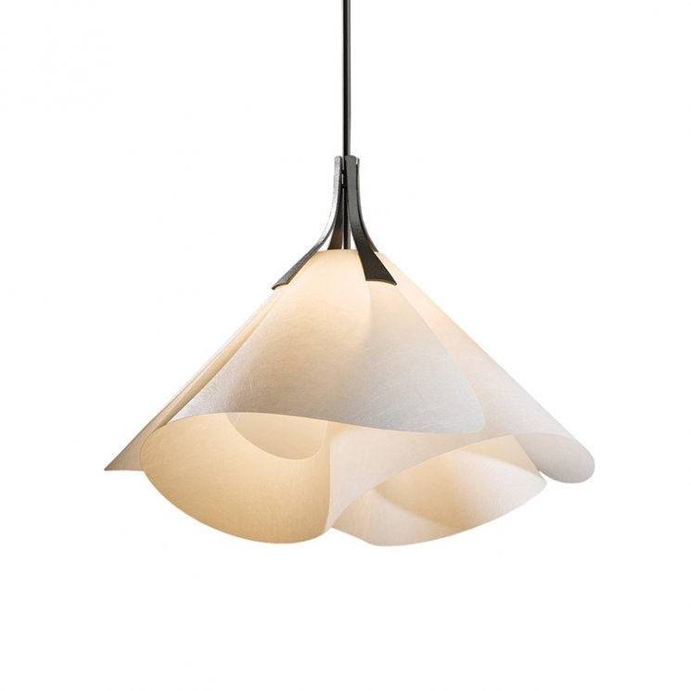

Discover the Mobius Strip with the Mobius Large Pendant. Designed by Hubbardton Forge's award-winning artisans, the softened Mobius design centers around a continuous form that flows in and out of itself in one single piece, simultaneously representing both an inside and outside boundary.